# RHPWG Shared Database Subcommittee

Conference Call December 13, 2018

DRAFT Notes

1. **Roll Call**

*Ed M – Albuquerque*

*Ryan T - AZ*

*Kristen M – MT*

*Brandon M – MT*

*Frank F - NV*

*Cindy H – NM*

*Roslyn H – NM*

*Shawn M – CIRA*

*Ted F - CIRA*

*Tom M – WRAP/WESTAR*

1. **Administrative**
   1. Current Notes – NV DEP
   2. Last month’s notes at <https://www.wrapair2.org/RHP_SharedDB.aspx> (bottom of page)

*Last month’s notes by Montana are posted on the Shared Database webpage.*

1. **Documentation discussion**
   1. FAQs – Keep those questions coming (preferably with answers!)

*CIRA has initiated a FAQs list based on the previous TSS’s FAQs, organized by topic. The FAQs represent a range of questions and will serve as a living document. The FAQ’s will be posted to the docket version by version to memorialize. Consensus for the current version will be sought during the next sub-committee call. Discussion regarding the distinction between FAQs and guidance, which may depend on tone. CIRA suggested FAQ high-level responses with links to more detailed information or resources. The FAQs will be distributed for review and feedback from the subcommittee by January 4, Friday. A revised FAQs will be distributed for subcommittee consensus on the next call, January 10, Thursday.*

* 1. Minimum functionalities – volunteer to develop initial draft? Ideas of what to include? Is there a version from the TSS v1?

*Discussion by sub-committee on the meaning of minimum functionalities which CIRA cleared up by identifying minimum functionality as bare minimum required to support regional air quality planning and SIP development (i.e., the needed functions, data, and displays) and suggested collaboration with the RHPWG to identify. Bells and whistles can be added but need to address the regional haze rule requirements. The sub-committee will start a list of RHR requirements, starting with the data (i.e., post substituted IMPROVE monitor data on TSS) and then how the data is presented. Asked for volunteers to start this process with a goal to finalize by the 1st Q 2019. Ryan T agreed to contribute in January and will start a list to present during the January 10 call. Membership asked to identify other documentation issues or thoughts and think about how to reach out to other WGs/SCs.*

1. **Discussion of charts - explanations**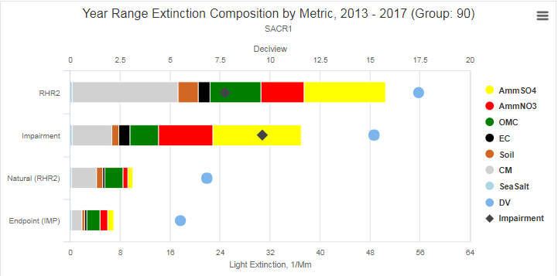
   1. (Open questions on chart interpretation)

*Continuation of discussion regarding this graphic from last call. CIRA is working with Scott Copeland, IMPROVE Steering Committee, on QA/QC of graphics packages. Noted that Natural (RHR2) is equal to NCII while Endpoint (IMP) is the natural conditions estimate that falls out of the most impaired days calculation. Discussion of semantics of labels and suggestions for Legend or Explanation (include deciview as unit of measurement for DV and Impairment or DV-Episodic-Routine Natural equals Impairment as a footer to graphic).*

*The graphics titles are Ted’s best first shot, the sub-committee should review all titles to ensure clarity of content and purpose, better titles will reflect the data presented and how it’s grouped. Noted that titles and labels should be consistent with the Monitoring Data and Glide Path Summary document.*

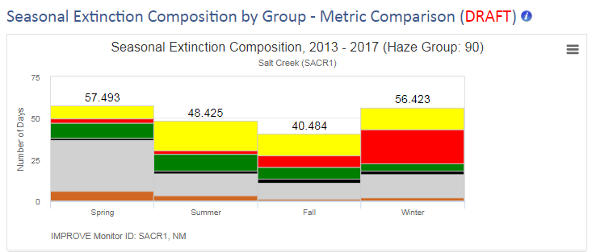

* 1. (Seasons ≠ calendar quarters; Does this really measure number of days?)

*Seasons (e.g., winter = December, January, February) would be consistent with emission inventory quarters, but recognized this isn’t the best approach for RH planning. Because we present monitoring data by calendar years, these types of graphics should be on a quarterly basis. This graphic shows seasonal averages over a 5-year period, but suggested that graphics have capability to display quarterly data for a period of several years. Noted that this type graphic requires horizontal real estate, also observed that some graphics are important for data interpretation and some will be incorporated into RH SIPs.*

*Subcommittee to identify comparison-type graphics for presentation ideas with a goal of finalizing monitoring displays prior to moving on to emissions graphics. It was suggested that the quarters indicate the number of most impaired days in each quarter, whether an average or MIDs. Noted that this display may be incorrectly labeled (too many days at top of each quarter, is the Y axis number of days or extinction value?) and should honor the most impaired days calculation methodology.*

1. **Action Items**

*All team members:*

* *Review labels, ensuring consistency with WRAP documents.*
* *Review titles and suggest revisions that are descriptive.*
* *Consider where we need informational pop-ups or links to documents. Send suggestions to Cindy for compilation.*
* *For which types of charts might we want to compare years or sites? (This is a “horizontal real estate issue” so we need to be judicious about it.)*

*Shawn and Ted*

* *Compile “seasonal” data by calendar quarters. Label them as quarters, rather than seasons.*

*Cindy*

* *Put page numbers and version information in FAQ document and distribute to team.*
* *Start minimum functionalities list.*

1. **Next call scheduled: January 10, 2019 at 10:00 am (CARB scheduled for note-taking)**

|  |  |
| --- | --- |
| 12.13.2018 | NV DEQ |
| (12.27.2018) | *No meeting* |
| 1.10.2019 | CARB |
| 1.24.2019 | *Cindy unavailable* |
| 2.14.2019 | NMED |
| 2.28.2019 | CABQ |
| 3.14.2019 | MT DEQ |
| 3.28.2019 | AZ DEQ |